Anton Sudarisman
Email: anton@primatalenta.com Tel : (62) 811425835

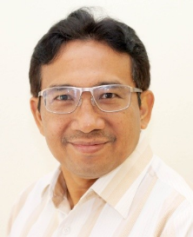
Anton Sudarisman is an expert in Human Capital Management and Leadership with qualifications including being a candidate of Ph. D. in People and Organization Development, Master’s Degree in Management (MM), Diploma in Training and Assessment, S1/Bachelor in English Education Studies.

Anton also has rich and extensive experiences in the area of Human Capital Management, with his latest position as Head of Human Capital Management for PT Amman Mineral/Newmont Nusa Tenggara, a large mining company operating in Sumbawa, Nusa Tenggara Barat. Previously, he hold managerial positions at other multinational companies including Riotinto Plc. (at its subsidiaries Kaltim Prima Coal and Kelian Equiatorial Mining), BHP Billiton Indonesia and Inco/Vale; with a number of global work assignments at international offices in Toronto, Rio de Janerio, Singapore, Perth and Denver.

Anton is a certified facilitator from DDI (Dimension Development International) for Leadership and Soft skills, Paradigm Learning for Business Simulations (Finance for Non Finance, Project Management, Change Management and Leadership), Proudfoot Consulting (Business Simulations for Productivity Improvement and Effective Supervision), Achieve Global (for Managing Cultural Diversity), Human Rights Commission (for Human Rights Fundamentals for Private and Public Sectors). Besides, he is also a certified Human Resource Manager and Competency Assessor for Indonesian National Professional Certification Commission (BNSP). Anton is also a master trainer for “Pelatihan dan Bimbingan Sertifikasi Profesi Managemen SDM (SKKNI MSDM Badan Nasional Sertifikasi Profesi).

